# DESIGN

Main

# Initialize variables

# input

# isbn

# counter

# checksum

# Output: “Enter the first 12 digits of the ISBN13”

# is input.length() == 12?

# if no, Output: input + “is an invalid isbn”

# if yes isbn = input.toCharArray()

# Loop: counter = 0, while counter<12

# if isbn[counter] is not a digit: Output: isbn + “is an invalid input”

# if counter in {0,2,4,6,8,10}: checksum = checksum + isbn[counter]

# if counter in {1, 3, 5, 7, 9, 11}: checksum = checksum + 3 * isbn[counter]

# checksum = 10 – checksum/10

# if checksum = 10, set checksum = 0

# output: “The isbn13 is “ + input + checksum

Flow Chart

# TEST PLAN

|  |  |  |
| --- | --- | --- |
| Test # | Input | Expected Output |
| 1 | 978013213080 | The ISBN-13 number is 9780132130806 |
| 2 | 978013213079 | The ISBN-13 number is 9780132130790 |
| 3 | 97801320 | 97801320 is an invalid input |

# SCREEN SHOTS

1

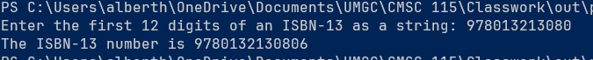

2



3

